**Tutorial 8**

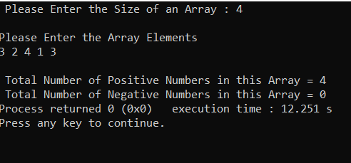**Q1.**

#include<stdio.h>

int main()

{

int Size, i, a[10];

int Positive_Count = 0, Negative_Count = 0;

printf(" Please Enter the Size of an Array : ");

scanf("%d", &Size);

printf("\nPlease Enter the Array Elements\n");

for(i = 0; i < Size; i++)

{

scanf("%d", &a[i]);

}

for(i = 0; i < Size; i ++)

{

if(a[i] >= 0)

{

Positive_Count++;

}

else

{

Negative_Count++;

}

}

printf("\n Total Number of Positive Numbers in this Array = %d ",

Positive_Count);

printf("\n Total Number of Negative Numbers in this Array = %d ",

Negative_Count);

return 0;

}

**Q2.**

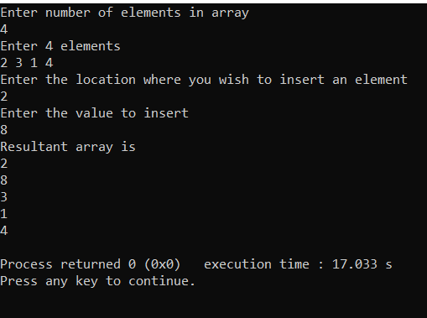#include<stdio.h>

int main()

{

int array[100], position, c, n, value;

printf("Enter number of elements in array\n");

scanf("%d", &n);

printf("Enter %d elements\n", n);

for (c = 0; c < n; c++)

scanf("%d", &array[c]);

printf("Enter the location where you wish to insert an element\n");

scanf("%d", &position);

printf("Enter the value to insert\n");

scanf("%d", &value);

for (c = n - 1; c >= position - 1; c--)

array[c+1] = array[c];

array[position-1] = value;

printf("Resultant array is\n");

for (c = 0; c <= n; c++)

printf("%d\n", array[c]);

return 0;

}

**Q3.**

#include <stdio.h>

int main()

{

int array[100], position, c, n;

printf("Enter number of elements in array\n");

scanf("%d", &n);

printf("Enter %d elements\n", n);

for (c = 0; c < n; c++)

scanf("%d", &array[c]);

printf("Enter the location where you wish to delete element\n");

scanf("%d", &position);

if (position >= n+1)

printf("Deletion not possible.\n");

else

{

for (c = position - 1; c < n - 1; c++)

array[c] = array[c+1];

printf("Resultant array:\n");

for (c = 0; c < n - 1; c++)

printf("%d\n", array[c]);

} return 0;

}

**Q4.**

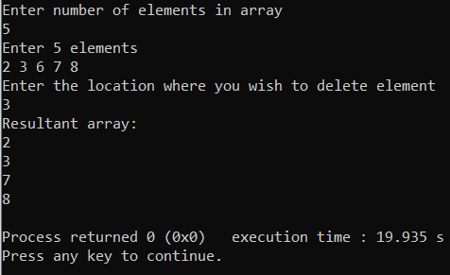#include <stdio.h>

int main()

{

int c,copied [100],arr1[100];

int size, i;

c=size-1;

printf("Enter size of the array: ");

scanf("%d", &size);

printf("Enter elements in array: ");

for(i=0; i<size; i++)

{

scanf("%d", &arr1[i]);

}

printf("\nArray in reverse order:\n ");

for(i = size-1; i>=0; i--)

{

printf("%d\t", arr1[i]);

}

for(i= 0;i<size;i++) {

copied[size-1] = arr1[i];

c--;

}

printf("\nagain reversing the array:\n");

for(int i=0;i<size;i++)

{

printf("%d \t", arr1[i]);

}

return 0;

}

**Q5.**

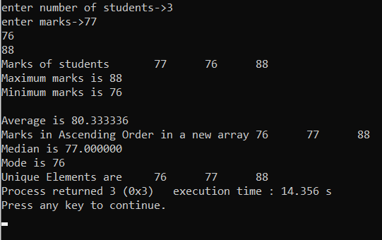#include<stdio.h>

void main()

{

int marks[50],marks2[50],marks3[50];

int i,j,k,n;

int min,max,sum,temp,mode,temp_mode,frq=0,

temp_frq,x1,c;

float avg,a1,med;

printf("enter number of students->");

scanf("%d",&n);

printf("enter marks->");

for(i=0;i<n;i++)

{

scanf("%d",&marks[i]);

marks3[i]=-1;

}

//Printing Marks of Student

printf("Marks of students\t");

for(i=0;i<n;i++)

{

printf("%d\t",marks[i]);

}

//Printing Highest and Lowest Marks

min=marks[0];

max=marks[0];

for(i=0;i<n;i++)

{

if(min>marks[i])

{

min=marks[i];

}

if(max<marks[i])

{

max=marks[i];

}

}

printf("\nMaximum marks is %d\n",max);

printf("Minimum marks is %d\n",min);

//Printing Average Marks

sum=0;

for(i=0;i<n;i++)

{

sum= sum+marks[i];

}

avg= (float)sum/(float)n;

printf("\nAverage is %f\n",avg);

//Arranging in ascending Order

for(i=0;i<n;i++)

{

for(j=i+1;j<n;j++)

{

if(marks[i]>marks[j])

{

temp=marks[i];

marks[i]=marks[j];

marks[j]=temp;

}

}

}

//Saving non-decreasing order in new array

i=0;

k=0;

while(i<n && k<n)

{

marks2[k++]=marks[i++];

}

printf("Marks in Ascending Order in a new array\t");

for(k=0;k<n;k++)

{

printf("%d\t",marks2[k]);

}

//Printing Median

x1=n/2;

a1= ((float)marks[x1-1] + (float)marks[x1])/(float)2;

if(n%2==0)

{

med= a1;

}

else

{

med= marks[x1];

}

printf("\nMedian is %f",med);

mode=marks[0];

for(i=0;i<n;i++)

{

temp_frq=0;

temp_mode=marks[i];

for(j=i;j<n;j++)

{

if(marks[j]==temp_mode)

temp_frq++;

}

if(temp_frq>frq)

{

frq=temp_frq;

mode=temp_mode;

}

}

printf("\nMode is %d\n",mode);

for(i=0;i<n;i++)

{

c=1;

for(j=i+1;j<n;j++)

{

if(marks[i]==marks[j])

{

c++;

marks3[j]=0;

}

}

if(marks3[i]!=0)

{

marks3[i]=c;

}

}

printf("Unique Elements are\t");

for(i=0;i<n;i++)

{

if(marks3[i]==1)

{

printf("%d\t",marks[i]);

}

}

}